This document is merely to point out the differences in confessional count numbers between my findings and the official numbers posted on Survivor Sucks. The guidelines I use can be found [here](https://docs.google.com/document/d/18ofsPiVWxSejzSjEGlU8KEx4Og2ddEJScCV23RsCPIA/edit?usp=sharing).

**Survivor Sucks Season 01 Counts** ([link](https://goo.gl/photos/3tMLvksMVgewy9gc9))

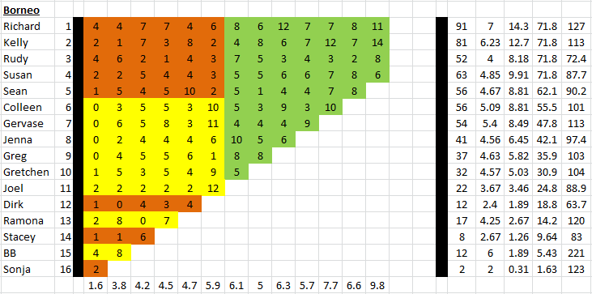

**My Season 01 Counts** (link)

**Differences**

[Episode 01](https://docs.google.com/document/d/1wkxNW33NryLUP1mo0jHYFoMz9saf0wIf_YRv-jYsa_g/edit?usp=sharing)

* **BB 3 (-1)** I got a total of 3 confessionals for BB instead of the established 4. No significant gaps.
* **Note:** Confessionals #12 & #13 are on-the-fly confessionals.

Episode 0

**No Change**

* Episode

|  |  |  |
| --- | --- | --- |
| **Castaway** | **Count** | **Change** |
|  |  |  |
| **Total** |  |  |

**Revised Sucks Counts** (link)